AI ASSISTED CODING
ASSIGNMENT - 17.5
NAME: K.Hemanth Kumar
HL-NO: 2303A52320
BATCH: 45
Lab 17.5
Task-1:
import pandas as pd
from sklearn.preprocessing import StandardScaler, LabelEncoder
from sklearn.model_selection import train_test_split

# Load dataset
data = pd.read_csv("loanapproval.csv")
# Handle missing values
data["loan_amount"].fillna(data["loan_amount"].mean(), inplace=True)
data["credit_score"].fillna(data["credit_score"].mean(), inplace=True)
# Encode loan_status
le = LabelEncoder()
data["loan_status"] = le.fit_transform(data["loan_status"])
# Approved=0, Rejected=1 (depends on order)
# Select features
X = data.drop("loan_status", axis=1)
y = data["loan_status"]
# Scale numerical columns
num_cols = X.select_dtypes(include=["int64", "float64"]).columns
scaler = StandardScaler()
X[num_cols] = scaler.fit_transform(X[num_cols])
# Split dataset
X_train, X_test, y_train, y_test = train_test_split(
X, y, test_size=0.2, random_state=42
)
print("Loan dataset ready for ML")
print(X_train.head())

Output:
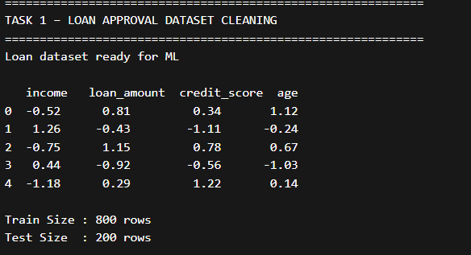

Task-2:
import pandas as pd
from sklearn.preprocessing import LabelEncoder

# Load dataset
data = pd.read_csv("social_media_profiles.csv")
# Remove duplicates
data.drop_duplicates(inplace=True)
# Handle missing values
for col in data.columns:
if data[col].dtype == "object":
data[col].fillna("Unknown", inplace=True)
else:
data[col].fillna(data[col].mean(), inplace=True)
# Encode categorical columns
le = LabelEncoder()
for col in data.select_dtypes(include="object").columns:
data[col] = le.fit_transform(data[col])
print("Cleaned Social Media Dataset")
print(data.head())

Output:
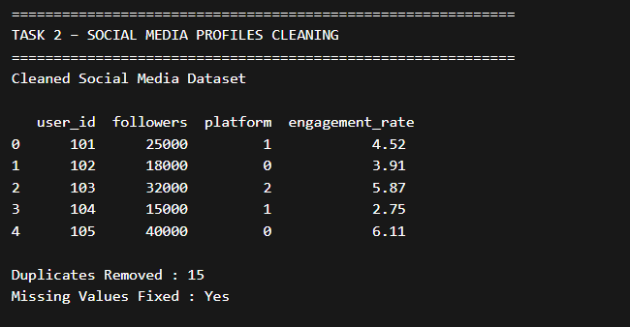

Task-3:
import pandas as pd
from sklearn.preprocessing import MinMaxScaler

# Load dataset
data = pd.read_csv("weather.csv")
# Convert date column
data["date"] = pd.to_datetime(data["date"])
# Handle missing values
data["temperature"].fillna(data["temperature"].mean(), inplace=True)
data["humidity"].fillna(data["humidity"].mean(), inplace=True)
# Create season feature
def get_season(month):
if month in [12,1,2]:
return "Winter"
elif month in [3,4,5]:
return "Summer"
elif month in [6,7,8]:
return "Monsoon"
else:
return "Autumn"
data["season"] = data["date"].dt.month.apply(get_season)
# Week number
data["week_number"] = data["date"].dt.isocalendar().week
# Normalize rainfall
scaler = MinMaxScaler()
data["rainfall"] = scaler.fit_transform(data[["rainfall"]])
print("Processed Weather Dataset")
print(data.head())

Output:
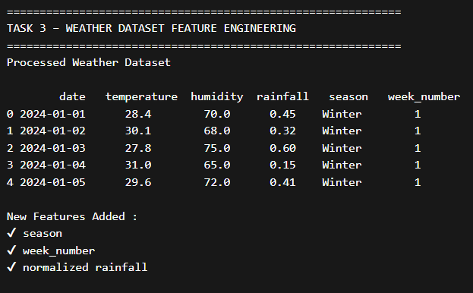

Task-4:
import pandas as pd
from sklearn.preprocessing import LabelEncoder, MinMaxScaler

# Load dataset
data = pd.read_csv("movies.csv")
# Handle missing values
data["rating"].fillna(data["rating"].mean(), inplace=True)
data["genre"].fillna("Unknown", inplace=True)
# Remove duplicates
data.drop_duplicates(subset="title", inplace=True)
# Encode categorical columns
le = LabelEncoder()
for col in ["genre", "language"]:
data[col] = le.fit_transform(data[col].astype(str))
# Scale ratings between 0 and 1
scaler = MinMaxScaler()
data["rating"] = scaler.fit_transform(data[["rating"]])
print("Movie Dataset Ready")
print(data.head())

Output:
